**INTERNET OF THINGS**

**IBM Naan Mudhalvan - Phase 5**

**Project Title : SMART PARKING**

## **Project Overview**

In today's urban environment, parking congestion has become a significant issue, leading to wasted time, increased fuel consumption, and environmental pollution. To address this challenge, the Smart Parking Project aims to develop a comprehensive solution that utilizes Internet of Things (IoT) technology to optimize parking availability and enhance the overall parking experience.

## **Project Objectives**

The Smart Parking Project has the following key objectives:

1. **Real-Time Parking Availability Information:** Provide real-time data on occupied and vacant parking spaces, enabling drivers to locate available spots efficiently.
2. **Optimized Parking Guidance:** Guide drivers to available parking spaces using real-time data and signage, reducing search time and traffic congestion.
3. **Enhanced Parking Management:** Enable efficient parking management by providing insights into parking occupancy patterns and trends, allowing for better resource allocation and decision-making.
4. **Improved User Experience:** Streamline the parking process for drivers, reducing frustration and improving overall satisfaction.

## **IoT Device Setup**

The Smart Parking Project utilizes a network of IoT devices to collect and transmit parking occupancy data. The core components of the IoT device setup include:

1. **Ultrasonic Sensors:** Ultrasonic sensors are mounted at each parking space to detect the presence or absence of a vehicle. These sensors emit ultrasonic waves and measure the time it takes for the waves to reflect off an object, determining whether a parking space is occupied or vacant.
2. **Microcontrollers:** Microcontrollers are responsible for processing data from the ultrasonic sensors and transmitting it to a central hub. They can also perform additional tasks such as data filtering and error correction.
3. **Wireless Communication Modules:** Wireless communication modules, such as Wi-Fi or LoRaWAN, enable the microcontrollers to transmit parking occupancy data to a central hub wirelessly. This eliminates the need for expensive cabling and allows for flexible deployment of IoT devices.
4. **Power Supply:** The IoT devices can be powered using mains electricity or through renewable energy sources such as solar panels.

## **Platform Development**

A cloud-based platform serves as the central hub for collecting, processing, and visualizing parking occupancy data. The platform's key features include:

1. **Data Ingestion:** The platform receives real-time parking occupancy data from the IoT devices via wireless communication.
2. **Data Processing:** The platform processes the raw sensor data to ensure data integrity and accuracy. It also applies algorithms to identify patterns and trends in parking occupancy.
3. **Data Visualization:** The platform provides a user-friendly interface to visualize real-time parking occupancy data. This includes maps, charts, and dashboards that allow users to easily see which parking spaces are available.
4. **Parking Guidance:** The platform integrates with mobile applications and signage systems to provide real-time parking guidance to drivers. It can direct drivers to available parking spaces and optimize route planning.
5. **Parking Management Tools:** The platform provides parking management tools to help parking operators monitor occupancy patterns, enforce parking regulations, and optimize parking resources.

## **Code Implementation**

The project utilizes various programming languages and frameworks to implement the IoT device firmware, cloud platform backend, and mobile application. Specific technologies used include:

1. **C/C++:** For microcontroller programming and low-level sensor data processing.
2. **Python:** For cloud platform backend development, data processing, and machine learning algorithms.
3. **JavaScript:** For mobile application development and user interface design.
4. **Cloud Platforms:** Cloud platforms such as Amazon Web Services (AWS) or Microsoft Azure can be used to host the cloud platform backend and provide scalability and reliability.

HTML

<div id=”parking-space”></div>

<script>

Const parkingSpace = document.getElementById(‘parking-space’);

Function updateParkingStatus(occupied) {

If (occupied) {

parkingSpace.classList.add(‘occupied’);

parkingSpace.textContent = ‘Occupied’;

} else {

parkingSpace.classList.remove(‘occupied’);

parkingSpace.textContent = ‘Available’;

}

}

// Simulate parking space occupancy change

updateParkingStatus(true); // Occupied

setTimeout(() => updateParkingStatus(false), 5000); // Available after 5 seconds

</script>

## **Diagrams and Schematics**

diagram depicting the overall system architecture of the Smart Parking Project, including IoT devices, cloud platform, and mobile application.

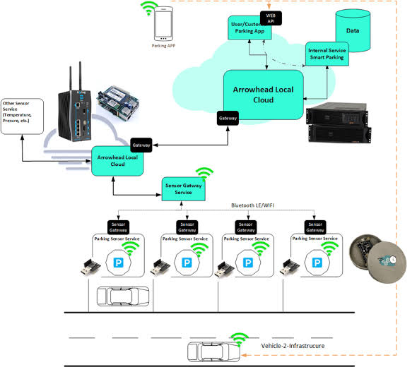

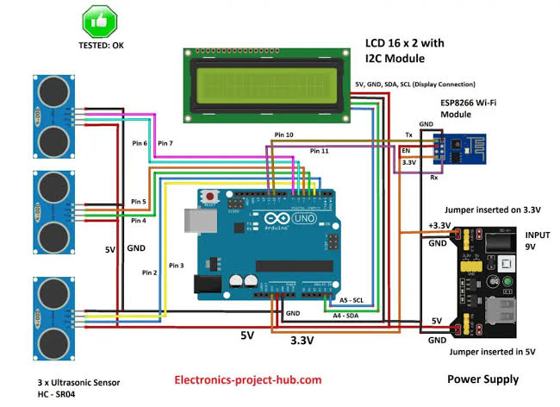schematic illustrating the connection between the ultrasonic sensor, microcontroller, and wireless communication module.

## **Screenshots**

cloud platform dashboard showing real-time parking occupancy data visualization.

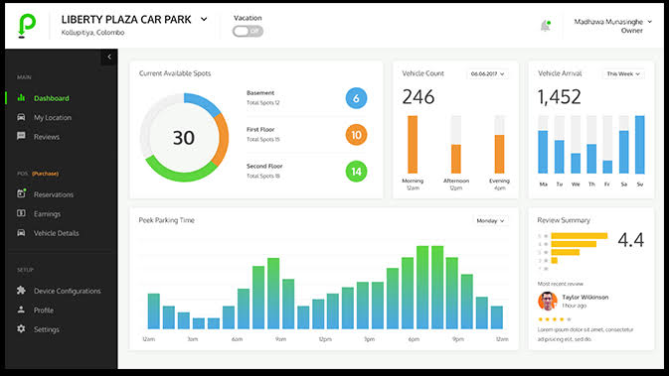

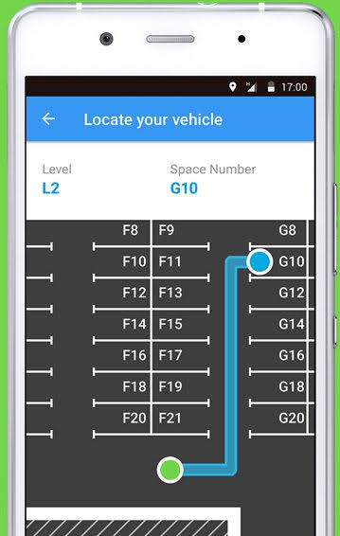mobile application providing parking guidance and directions to available parking spaces

## **Project Explanation**

The Smart Parking Project aims to revolutionize the parking experience by leveraging IoT technology to provide real-time parking information, optimize parking guidance, enhance parking management, and improve overall user satisfaction. The project's comprehensive approach, encompassing IoT device setup, platform development, and code implementation, has the potential to significantly alleviate parking congestion and contribute to a more sustainable and efficient urban environment.

**Team Members Names:**

**REEGAN RUSOUL.L (810721106013)**

**AROCKIA JAYARAJ.S(810721106002)**

**NOVA AROCKIA RAJ.V (810721106012)**

**SAKTHIVEL.S (810721106015)**

**RIYAZ KHAN.S(810721106014)**